SubTask 3.1: Completing the Group Session Initialization Protocol

To: kiranjain@gmail.com, misaonakano@gmail.com
Subject: Completing the Group Session Initialization Protocol

Dear Kirao and Misao,
I am writing this email to explain to you the steps in completing the group session initialization protocol.

First, there are a few missing steps at the end of Fig. 7. After performing the steps in Fig. 7, the user will have to perform a few more steps to ensure the group session maintains its integrity, authenticity and confidentiality.

Step 1: Extract the SESSID
As session IDs are unique, by extracting the session ID, the group members can identify their session and are able to distinguish it from other sessions. This ensures that the group members know that they are in the correct session.

Step 2: Verify the Signature of the Group Initiator
By ensuring that the signature of the group initiator is valid, other members will not be fooled by malicious group insiders pretending to be sending messages as other honest members. This maintains the group session’s integrity and authenticity.

Step 3: Decrypt the gsk
As the gsk is used to encrypt and decrypt group messages during the session, by decrypting the gsk, group members can obtain the shared encryption key needed to communicate within the group securely. This allows the group members to communicate with one another effectively while also maintaining the confidentiality of the group session.

Next, I will explain how to extract the SESSID and decrypt the gsk of a message that “DeltaZhang00” sent to “ALICEKerr000”.

Reading the Message
First, by using the command below, the contents of the message can be read.
Output:
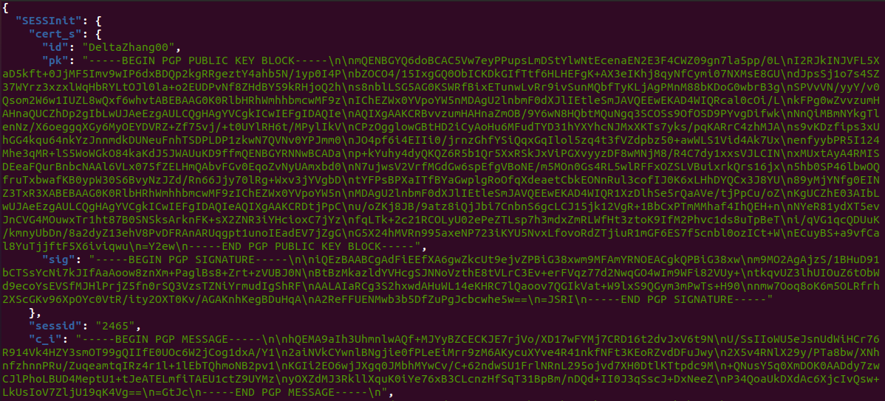

Extracting the SESSID
The session ID is obtained by using the command below.
Session ID: 2465

Decrypting the gsk
The ciphertext sent by “DeltaZhang00” is obtained using the command below.
Output:

As the ciphertext has additional text that is not needed, the command below removes the unnecessary parts.
Output:
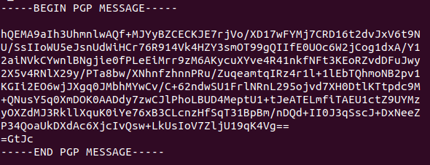

Next, using the command below, “ALICEKerr000”’s secret key is imported.
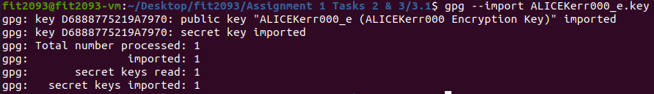
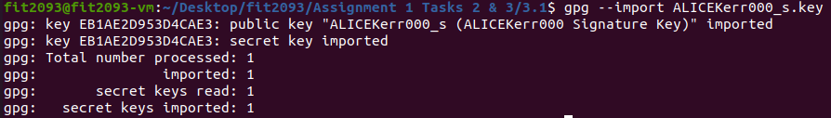
With the secret key, the decryption can proceed smoothly as it would have to verify the signature’s authenticity first.

Using the command below and “ALICEKerr000”’s obtained secret key, the ciphertext sent by “DeltaZhang00” is decrypted.
Output:
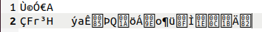

Finally, the plaintext is converted to a readable format (Hexadecimal) using the command below.
Output:
With that, the gsk (in Hexadecimal format) has been obtained.

I hope you find this email helpful in understanding how to complete the group session initialization.

Regards,
Braden

SubTask 3.2: Confidentiality of the Group Session Initialization Protocol

To: reyes2093@gmail.com
Subject: Confidentiality of the Group Session Initialization Protocol

Dear Reyes,
I am writing this email to explain about the potential threats and information available to passive and active attackers aiming to attack the user enrolment and group session initialization protocols.

User Enrolment: Passive Attack
I believe the system is safe from passive attacks and successfully maintains confidentiality. This is because not only is the user’s ID private and only known to the user who set it, the secret key is stored in the system and hidden from outsiders. This makes it difficult for outsiders to eavesdrop on conversations to pick up any sensitive information.

User Enrolment: Active Attack
The system is relatively safe from active attacks as well as the RSA signature and encryption key pairs are 2048 bits long. The length of the key pairs protects the system from brute force attacks, maintaining confidentiality.

Group Session Initialization: Passive Attack
Just like the user enrolment protocol, the group session initialization protocol is quite safe from passive attacks as well as the messages are encrypted.

Group Session Initialization: Active Attack
The system is at risk of an active attack due to how the user’s keys are handled. During the user’s enrolment, an attacker could alter the cert list of the user currently enrolling by replacing the user’s public encryption with their own. The group session initialization protocol would be unable to validate the user’s identity as their digital signature has not been established yet.

Once the attacker has replaced the target’s public key, the cert list is sent to the server and signed. This would allow the attacker to impersonate themselves as the target and compromise the gsk by decrypting it with their own private key when they receive a message sent by the group initiator.

I will demonstrate this method of attack below.
Attack Demonstration
First, using the commands below, “DeltaZhang00”’s (the initiator’s) key pairs are imported.
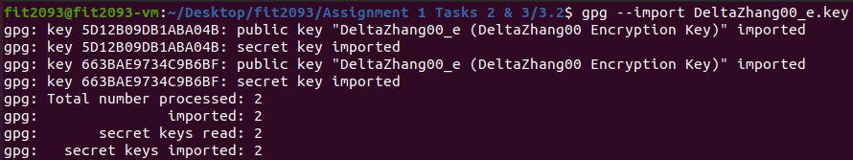
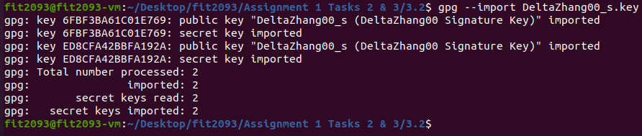

Next, using GPG, a key-pair is generated.
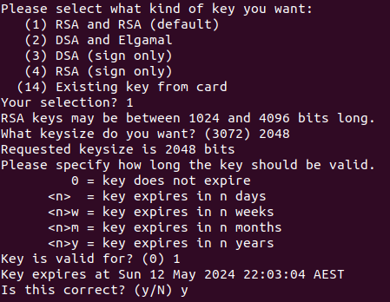
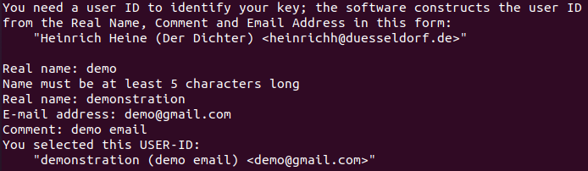
Type of Key: RSA and RSA
Key Length: 2048 bits
Expiration date: 1 day
Real Name: demonstration
Email Address: demo@gmail.com
Comment: demo email

After the key is created, the user would enter a password only they know to protect their new key. This ensures that only the user has access to their secret key.
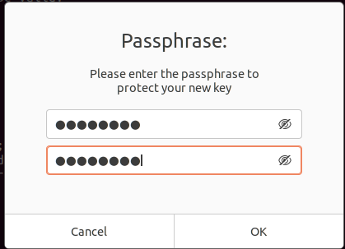

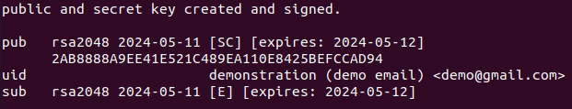
The public and secret key are now created.

Next, the public key is stored in a variable using the command below.

After storing the variable, the public encryption key of “PrincePhi123” is replaced with the public key generated prior using the command below.
“PrincePhi123”’s public key has been successfully replaced.

After that, the command below is used to simulate “DeltaZhang00” initiating a session with “PrincePhi123”, “CharlieLake0” and “ALICEKerr000”.
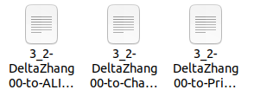

Next, the cihpertext sent to “PrincePhi123” (the target) is extracted using the command below.
Output:

The ciphertext is then converted to a suitable format (asc) using the command below.
Output:
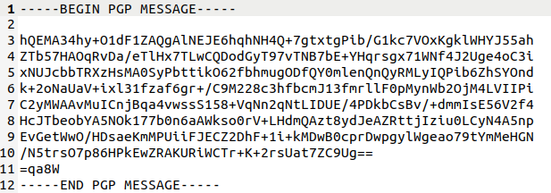

Using the command below, the ciphertext is decrypted to obtain the gsk.
Output:

Finally, the gsk is converted to Hexadecimal format using the command below.
Output:
With this, the gsk has been compromised by the attacker.

I hope you find this email helpful in understanding about the potential threats to the group session initialization protocol.

Regards,
Braden

